MODERNISATION
OF HIGHER EDUCATION
IN CENTRAL ASIA
THROUGH
NEW TECHNOLOGIES
( HiEdTec )

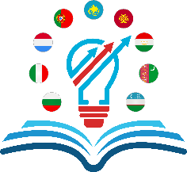

FIRST MEETING
11-15 March 2019

With the support of the Erasmus+ programme
of the European Union

