Erasmus+
Key Action 2
“Capacity Building in the Field
of Higher Education”

MODERNISATION
OF HIGHER EDUCATION
IN CENTRAL ASIA
THROUGH NEW TECHNOLOGIES
( HiEdTec )

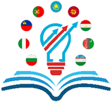

November 2018 – November 2021

COORDINATOR:
UNIVERSITY OF RUSE
https://www.uni-ruse.bg/en

HiEdTec 2
- REASONS:
In order to respond to:
- the Digital Transformation of Industries (Industry 4.0), which also requires DIGITAL TRANSFORMATION OF EDUCATION with overtaking pace, the consortium will develop CONCEPTS OF ADAPTING THE EDUCATIONAL SYSTEM TO THE DIGITAL GENERATION considering the specific conditions of each of the partner countries;
- the requirement of the EU to give the opportunity for EVERYBODY to learn at ANY time and at ANY place with the help of ANY lecturer using ANY device – computer, laptop, tablet, phablet, smart phone, etc. the consortium will create CENTRES FOR INNOVATIV EDUCATIONAL TECHNO- LOGIES.
- MAIN PROJECT OUTCOMES AND PRODUCTS:
- Sustainable academic network for sharing experience and exchange of good practices in the field of innovative educational technologies and didactic models;
- 5 Concepts of adapting the education system to the digital generation - 1 per partner country (PC);
- 15 Centres for innovative educational technologies - 1 at each PC university;
- 45 active learning classrooms - 3 at each PC university;
- Virtual classrooms – 1 at each PC university;
HiEdTec 3

- Handbook of innovative educational technologies;
- Courses for trainers for the acquisition of digital skills and learning methods;
- Courses for lecturers for the acquisition of digital skills and learning methods;
- 75 e-Learning courses - 5 at each PC university;
- 75 PowerPoint presentations of lectures suitable for delivery using interactive electronic white board - 5 at each PC university;
- Cloud-based Virtual Library of the digital educational resources.

- IMPACT:
- The project products will be of benefit to all stakeholders in education:
• National and university policy-makers in the field of education;
• University academics who are trainers / lecturers / learners;
• Scientific, economic and social partners.
- The project will help to turn partner universities into innovative universities and to improve the quality of the trained specialists, who are necessary to perform the Digital Transformation of Industries (Industry 4.0).

HiEdTec 4
- PARTNERS:
19 universities from:
- BULGARIA
- ITALY
- LUXEMBOURG
- PORTUGAL
- KAZAKHSTAN
- KYRGYZSTAN
- TAJIKISTAN
- TURKMENISTAN
- UZBEKISTAN
5 MINISTRIES of EDUCATION of the CENTRAL ASIAN COUNTRIES.

1. BULGARIA
University of Ruse

2. ITALY
University of Pavia

3. LUXEMBOURG
University of Luxembourg

4. PORTUGAL
Coimbra University

5. KAZAKHSTAN
- Almaty Technological University
- Innovative University of Eurasia
- L.N. Gumilyov Eurasian National University
- Ministry of Education and Science

6. KYRGYZSTAN
- Ala-Too International University
- Issyk-Kul State University named after K. Tynystanov
- Kyrgyz State Technical University named after I. Razzakov
- Ministry of Education and Science

HiEdTec 5

7. TAJIKISTAN
- Khorog State University named after M. Nazarshoev
- Tajik Technical University named after Academician M. Osimi
- Technological University of Tajikistan
- Ministry of Education and Science

8. TURKMENISTAN
- International University for the Humanities and Development
- Oguz Han Engineering and Technology University of Turkmenistan
- State Power Engineering Institute of Turkmenistan
- Ministry of Education

9. UZBEKISTAN
- Andijan Machine-Building Institute
- Tashkent State University of Economics
- Tashkent University of Information Technology
- Ministry of Higher and Secondary Specialized Education

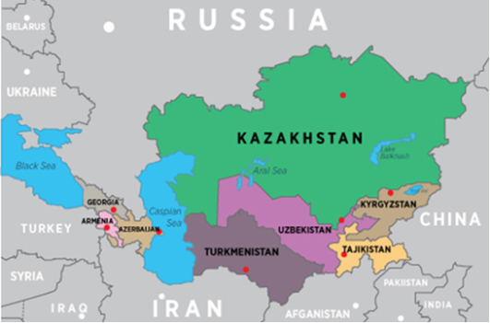

HiEdTec 6
- CONTACT INFORMATION:
All e-mails concerning HiEdTec should be addressed to the COORDINATOR Angel Smrikarov, to the VICE-COORDINATOR Tzvetomir Vassilev and to the MANAGER Stoyanka Smrikarova
ASmrikarov@ecs.uni-ruse.bg
TVassilev@ecs.uni-ruse.bg
SSmrikarova@ecs.uni-ruse.bg

All post-mails should be sent to the COORDINATOR Angel Smrikarov:
University of Ruse
8 Studentska Street
7017 Ruse, BULGARIA

Tel.: +359 82 / 888 743
Fax: +359 82 / 841 621
- IMPORTANT
Further information is available at
http://hiedtec.ecs.uni-ruse.bg

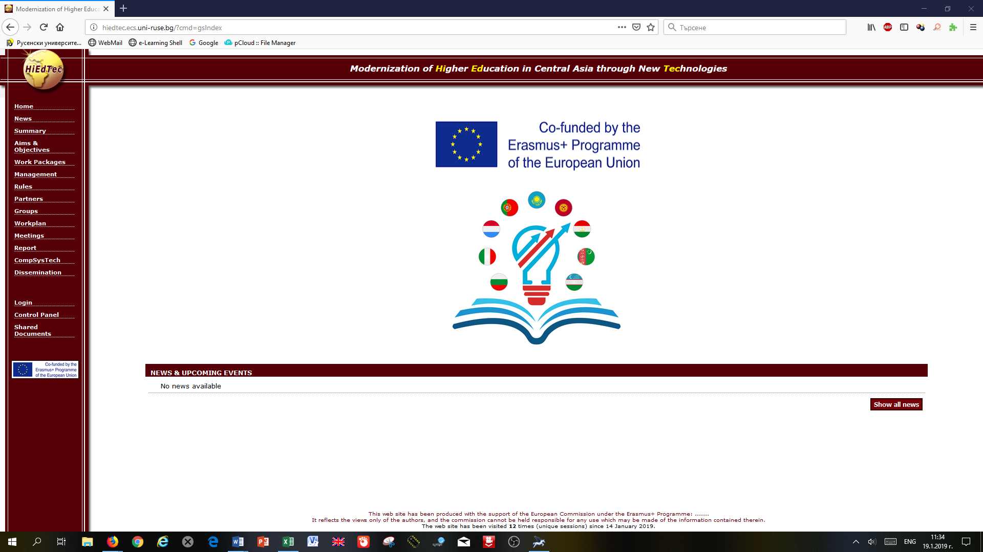

Conference CompSysTech
http://www.compsystech.org

INDEXED BY SCOPUS

