http://hiedtec.ecs.uni-ruse.bg/

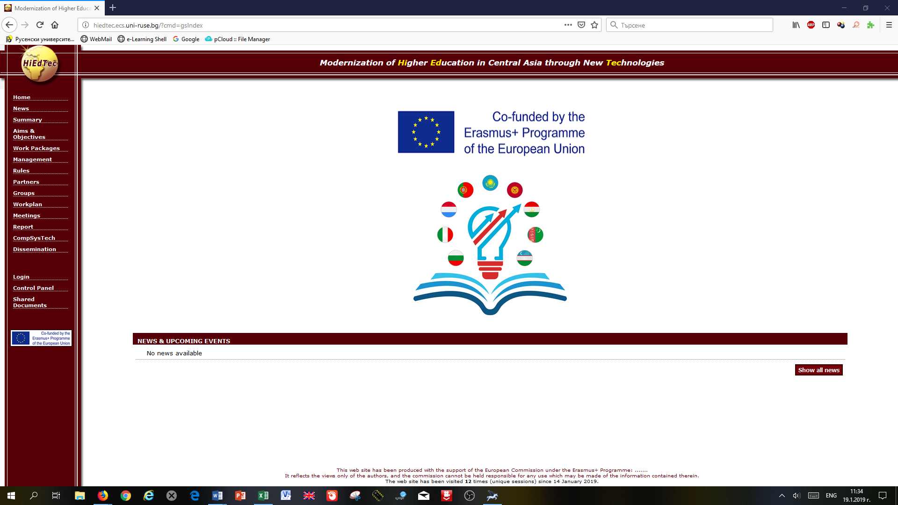

https://www.facebook.com/groups/1894619324189323/

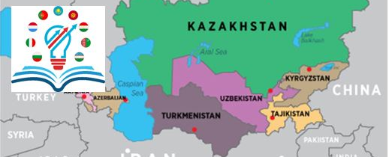
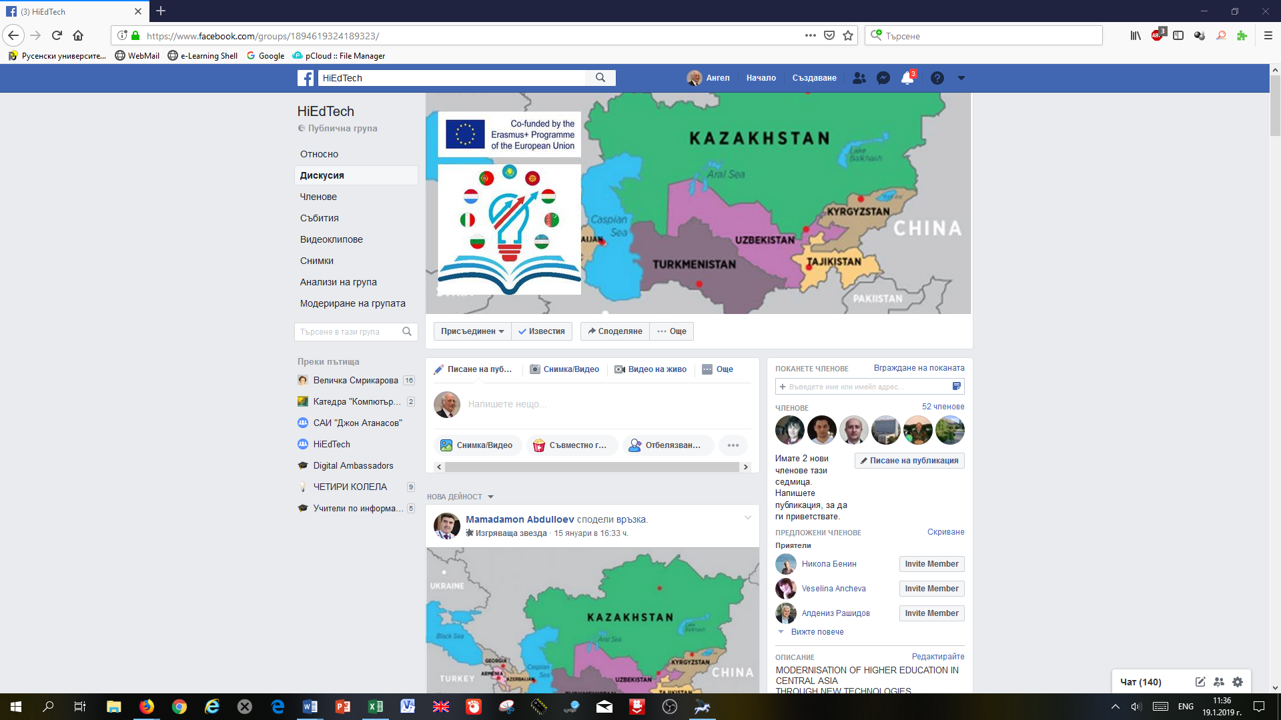

MODERNISATION
OF HIGHER EDUCATION
IN CENTRAL ASIA
THROUGH NEW TECHNOLOGIES
( HiEdTec )

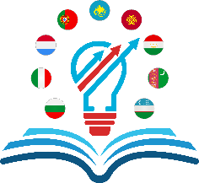

Together we can do more!

With the support of the Erasmus+ programme of the European Union

